Date: 03/12/2022

Author: Raghavendra Kamat

**CAE Driven Virtual Validation of Lighting performance**

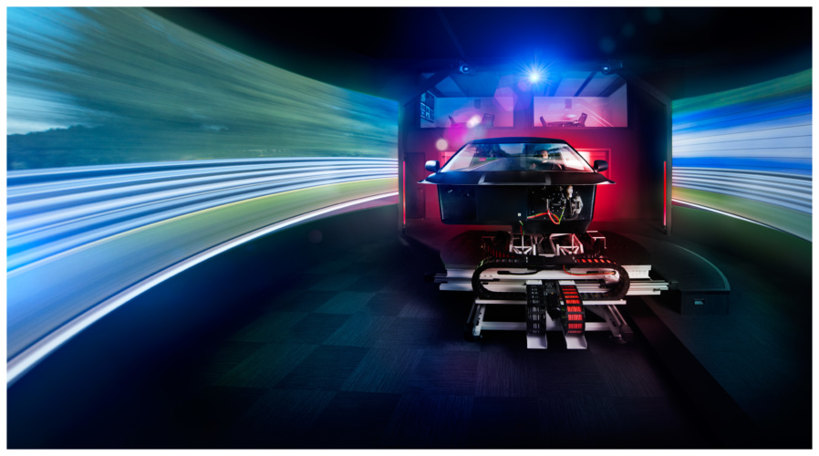

Modern Day Headlights serve many additional functions apart from illuminating the roadways. They are equipped with projector lamps with thermal management systems and integrated Daytime Running Lights (DRL). The housing of headlamps facilitates mounting points for front exterior systems, acts as a link between BIW and exteriors. Future headlamps also host many sensors and cameras of ADAS features. Headlamps of a Full-size SUV or a truck hosting all the innovative lightning technologies typically range from 6 to 8 kg/lamp. The majority of functional parts are mounted on Headlamp housing which also facilitates the hard and soft mountings for exterior sub-systems. Meeting the OEM performance standards for durability and regulatory requirements on the field is a challenging task for such heavy headlamps. But with the sophisticated CAE tools and the methodologies developed especially to meet headlamp performance requirement makes it easier to develop the product in a timely and cost-effective manner.

**What eShocan offer:**

Product development and virtual validation of Headlamp involves the prediction of loads, material selection, and optimized designing of headlamp body in a robust manner to meet all following design performance parameters with aid of available CAE tools and methodologies

**Design for Stiffness**

* Involves designing of Headlamp to meet established Natural frequency and FRF targets (typically ranges from 45 to 50hz)
* Headlamps with sensors, cameras for ADAS features, and washer system require a more robust design to meet frequency response and sensor-related targets
* Optimized tab attachment to the body, type of fastener, and its locations
* Optimized additional bracket design to support soft mounts for exterior and closure subsystems
* Tab deflection strength while assembling
* Aim deflection strength

**Design to Sustain for Fastener loads**

Headlamps mounted on pickup trucks, full-size SUVs, and offroad vehicles delivers high acceleration on the fasteners in case of a pothole or in an offroad event resulting in loosing of torque. This causes more stress on the other mounting tabs and cracks can develop. These types of failure can be avoided with selective load prediction and implementing the following design principles

* Predicting loads to each mounting tab.
* Involves designing of tabs and body brackets to overcome toque and shear loads
* Introducing steel compression limiter to the tabs where predicted loads exceed the fastener torque values.
* Reducing the overall mass of headlamp with CAE optimization

**Design for Durability and Fatigue**

* Design to meet the stresses caused by vibration fatigue from the shaker table test
* Design to meet the stresses caused by duty cycle fatigue
* Stress assessment for reinforced plastics with the help of DIGIMAT coupling
* Design to meet the cyclic thermal stresses caused by high and low temperatures
* Design to withstand the stress caused by a high acceleration in case of the pothole and offroad events

**Design for FMVSS/ECER Regulatory**

* Design to meet the FMVSS/ECER Low-speed regulatory requirements.
* Design to meet for the Pedro compliances

**Multi-Disciplinary Optimization**

eShocan offers multi-disciplinary optimization to meet all performance parameters with less lead design timeline.